

PRODUCT INFORMATION SHEET

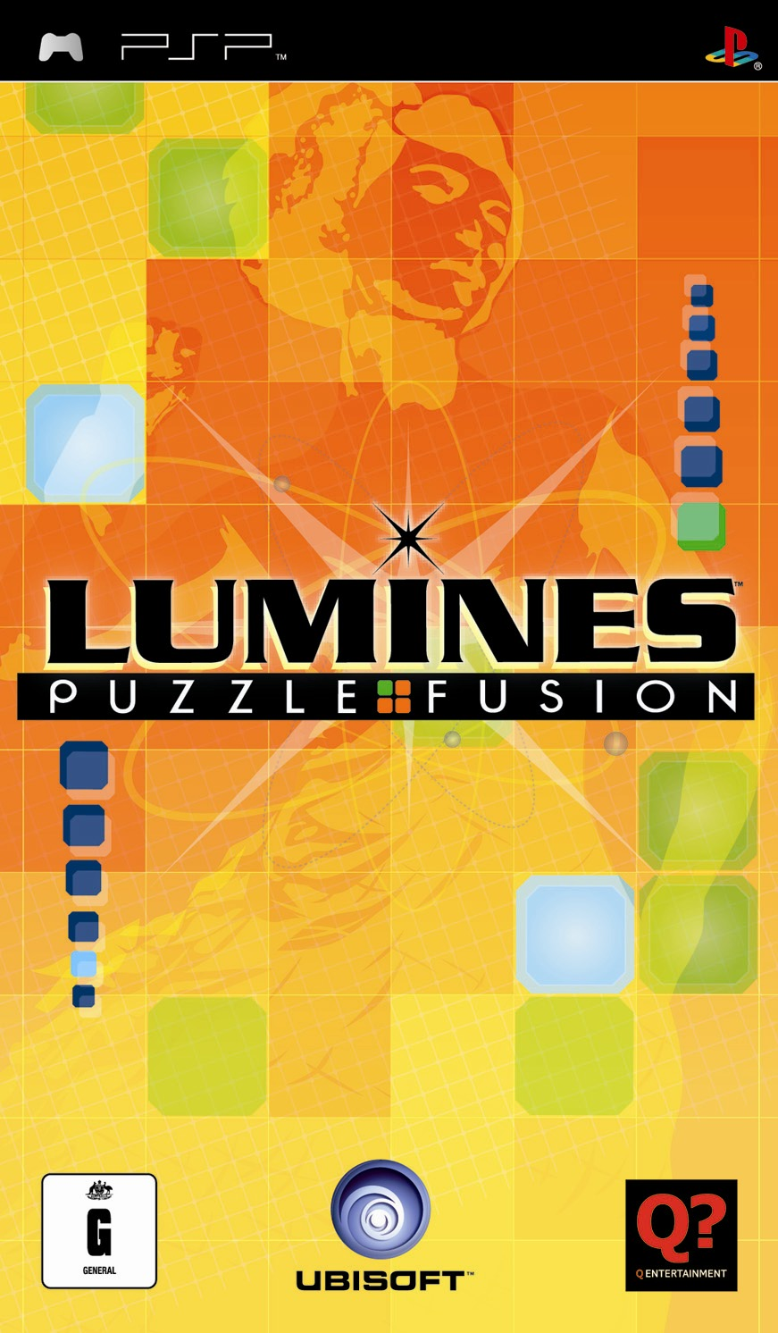

FORMAT: PSP™
GENRE: Musical puzzle game
RELEASE DATE: September 2005

DEVELOPPER: Q Entertainment
PUBLISHER: Ubisoft

MULTIPLAYER: 2 wireless
OFFICAL WEBPAGE: http://www.luminesgame.com

PRODUCT DESCRIPTION

An original PSP™ launch title, Lumines is an addictive, hip, and stylistic musical puzzler reminiscent of Tetris that promises to transcend any puzzle game to date.

Creator of REZ, Sega Rally, and Space Channel 5, renowned designer Tetsuya Mizuguchi delivers a unique gameplay experience that gives players the chance to bust blocks while grooving to evolving musical scores of rock, techno, and pop grooves.

SCREENSHOTS

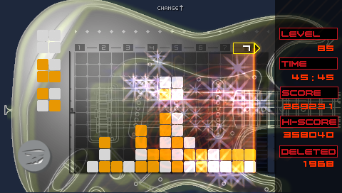
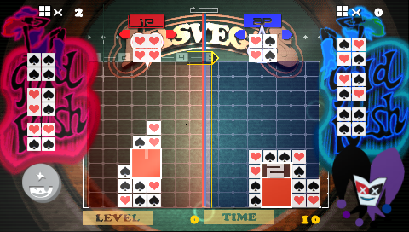

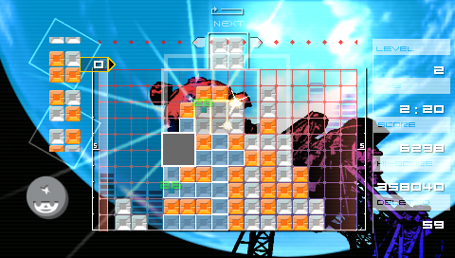
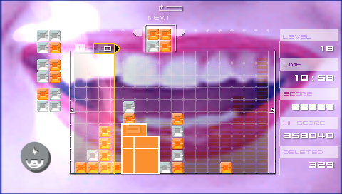

KEY FEATURES

A Simple Puzzler: Users are challenged to control a block until it lands on the ground, creating a square using blocks of the same color. In order to delete the square from the field, the shape must be larger than 2x2. The larger the square you delete, the higher your score

A Unique Puzzler: Any expanded square regions will be deleted when the Sequencing Bar passes by. A player’s success is determined by how far you can expand the square regions in order to delete large boxes at once

In Synch: Each key action generates sound effects. The flow of the Sequencing bar and the speed of the descending block are synchronized with the beat of the background music. Once a block is deleted, a music file is played. The more blocks destroyed in a sequence, the better the music

Single Player Modes: Enjoy 24 action/packed levels of graphics and music in Challenge Mode, race the clock and beat the odds in Time Attack Mode, earn graphical skins and avatars as you battle CPU characters in Duel Mode and draw shapes with blocks in Puzzle Mode.

Multi-player Functionality: Through Wireless technology, the user can compete with an opponent in the “VS.” Mode

Multiple Game Stages: Four stages, each with its own musical theme and sound effects, offer increasing levels of difficulty tied to beats-per-minute.

Changeable Skins: Users can earn graphical skins as they by clearing various stages throughout gameplay. Skins can then be changed to the users liking, much like a media player.

Collectible Characters: Players can increase their collection of characters by beating CPU characters and clearing stages. The user can show off their Lumines skills by using the characters they’ve earned as an avatar, giving them a unique identity.

